BDFI-RPIF Academic Advisory Group (AAG)
Terms of Reference
1.0 Context / Background
The Bristol Digital Futures Institute (BDFI) is a University Research Institute (URI), that will pioneer transformative sociotechnical approaches to digital innovation. Digital technologies are changing our world, for better and for worse. BDFI will develop in-depth systematic understanding of sociotechnical futures to drive the creation of digital technologies for inclusive, prosperous and sustainable societies. BDFI will harness the opportunities and address these challenges, it will create new knowledge and understanding of sociotechnical innovation – how technologies and societies shape the future together. This demands new ways of working: across disciplines, with partners from all sectors, with new facilities and spaces to support this ecosystem.
BDFI was awarded £29m capital funding from Research England’s Research Partnership Investment funding (RPIF) scheme for capital build and equipment. This was matched by £71m funding from a wide range of 27 external partners and a £16m contribution from the University of Bristol (UoB). As part of its commitment UoB will make 20 new academic appointments (10 in Social Sciences and 10 in Engineering) to provide research capacity to support delivery of RPIF outcomes.
The RPIF capital funding is for the construction (£20m) and equipping (£9m) of BDFI spaces listed on the bid on the Temple Quarter Enterprise Campus (TQEC). Originally this was to be in the CM1 building, however due to delays the majority of the larger flagship BDFI facilities and Institute Hub will now be delivered in the TQEC-The Sheds building. The remaining BDFI facilities will be delivered in CM1 in 2025. The RPIF funding enables BDFI to establish the Institute Hub and provide key specialist research facilities which include the Reality Emulator, Neutral Lab, Instrumented Auditorium and Studios, Digital Health Node and Cyber Security Infrastructure Suite.
The BDFI facilities will be available to all those who access the BDFI, including academic collaborators from other institutions, current and future partner organisations, as well as for some commercial use in compliance with State Aid rules.
The overall delivery and implementation of the RPIF award is the responsibility of the RPIF Delivery Board. It will direct the spend of RPIF funding, deliver the buildings and facilities, the required RPIF matched funding co-investment and outcomes, and oversee compliance with the terms and conditions of the award. The RPIF Delivery Board is chaired by the PVC Research and Enterprise as Institutional Lead of the RPIF award. RPIF funded buildings and facilities at TQEC will be delivered in phases starting in 2022 Retort House, 2023 Coal Shed and finally in 2025 with completion of CM1. However, delivery of the matched co-investment and outcomes will extend over a 10+ year period from time of award. As a result of the pandemic the funder has provided some additional flexibility beyond 10 years for delivery of the co-investment.
The BDFI-RPIF Academic Advisory Group has been established to provide academic guidance and support to the RPIF Delivery Board on delivery of the award, the matched co-investment from partners, and research outcomes over this 10+ year period and to support the development and growth of the Institute.

RPIF Dependencies
- RPIF funded construction of buildings and facilities for BDFI at TQEC – CM1, The Retort House and the Coal Shed (The Sheds)
- Realisation of RPIF partner £71m co-investment commitments over 10+ years
- Delivery of RPIF outcomes over 10+ years
- Coordination across other TQEC Institutes/Programmes/Initiatives/Facilities
2.0 Membership
BDFI brings together academic and research colleagues from all six faculties. Members of the AAG represent the colleagues and constituencies who will use the Institute’s facilities and can include Academics, Professional Service and / or Student representatives.
The AAG is initially comprised of colleagues appointed from research groups named in the Research England RPIF proposal and in some cases associated with specialist facilities funded by RPIF. These all form part of BDFI’s offer from which BDFI’s RPIF outcomes must be generated.
Appointments are for an initial period of 3 years, from June 2020. Membership of the AAG may increase or be altered as BDFI grows to encompass a wider range of activities beyond RPIF. Membership and function of the group will be reviewed in March 2022.
The AAG is co-chaired by BDFI’s two Academic Co-Directors Professor Susan Halford and Professor Dimitra Simeonidou.
Name | Role
Professor Susan Halford | Co-Chair, BDFI Academic Co-Director, Faculty of Social Science and Law
Professor Dimitra Simeonidou | Co-Chair, BDFI Academic Co-Director, Faculty of Engineering
Professor Dave Bull | MyWorld and VIL, Faculty of Engineering
Professor Ian Craddock | Digital Health, Faculty of Engineering
Professor Esther Dermott | Head of School for Policy Studies, Faculty of Social Science and Law
Professor Richard Owen | Prof in Innovation Management, Faculty of Social Science and Law
Professor Awais Rashid | Cyber Security, Faculty of Engineering
Currently vacant | Faculty of Social Science and Law
Dr Jenny Knapp | Director BDFI Programmes & Operations
Hayley Shaw | URI & Partnerships Manager
Chris Burton | Secretary

3.0 Group Responsibilities
The AAG supports the implementation of RPIF, the development of BDFI and the delivery of RPIF outcomes, specifically by:
- Representing academic constituencies relevant to the development of BDFI
- Providing interdisciplinary academic leadership advising on the development and long-term research strategy for BDFI and the success of BDFI as a URI
- Supporting the delivery of RPIF’s Critical Success Factors (CSF) and outcomes over a 10 year period
- Advising on the development of and reviewing planned and existing BDFI specialist facilities for sign off by the RPIF Delivery Board.
- Being consulted on the development and implementation of the operational model for BDFI and its facilities
- Providing advocacy for the BDFI within the University and externally, championing the Institute within their respective research communities and external networks, and bringing the perspective of these communities back to the AAG.
- Supporting the activities of the BDFI to successfully fulfil its mission statement
- Supporting and reviewing the alignment of BDFI’s objectives with the strategic objectives of the University.
- Support existing and facilitate new interdisciplinary collaborations and communities
- Contribute to the development and strengthening of BDFI research priorities and themes
- Advise on additional internal and external partners and funding opportunities, and offer other support as appropriate
- Recommend the outputs expected from BDFI Associated academics and researchers, evaluation criteria for these outputs and review the outputs and their impact.
- To attend quarterly AAG meetings and in-between to provide advice and input when required. To attend extraordinary meetings when called and advise on other BDFI activities as they emerge.
Where necessary, and identified and agreed by the AAG, sub-groups may be convened to work on specific projects.
4.0 Role of the AAG Co-Chairs
The AAG Co-Chairs are responsible for:
- the leadership of the AAG and its effectiveness, including ensuring that the Group acts within its responsibilities as set out in these Terms of Reference.
- promoting the AAG’s efficient operation, including ensuring the smooth-running of Group meetings, and ensuring that the Members work together effectively.
5.0 Quorum
The quorum necessary for the transaction of business is one third of the membership of the AAG (rounded to the nearest whole number). This must include at least one of the Co-Chairs.
6.0 Frequency of Meetings
The AAG will meet quarterly, with urgent issues being discussed between meetings via email. The Co-Chairs may request additional meetings if they consider it appropriate.
Business may be conducted by correspondence (including by email) where deemed appropriate by the Co-Chairs. A decision or recommendation taken by correspondence shall be valid as though taken at a meeting of the AAG, provided that a majority of the members of the AAG confirm by email that they are in favour of it.
Any decisions, recommendations or actions taken between meetings of the AAG shall be reported to the next meeting of the AAG.
Meetings can be held virtually or in person. If meetings are scheduled in person members of the AAG may request to attend virtually or by telephone if necessary. Virtual or telephone attendance at a meeting will be deemed equivalent to being in person and contributing the quorum.
Additional attendees can be invited to meetings where appropriate for specific agenda items.
7.0 Governance and Reporting
The AAG advises the BDFI Leadership Board which in turn reports into the RPIF Delivery Board and the BDFI (URI) Executive Board, see governance structure below:
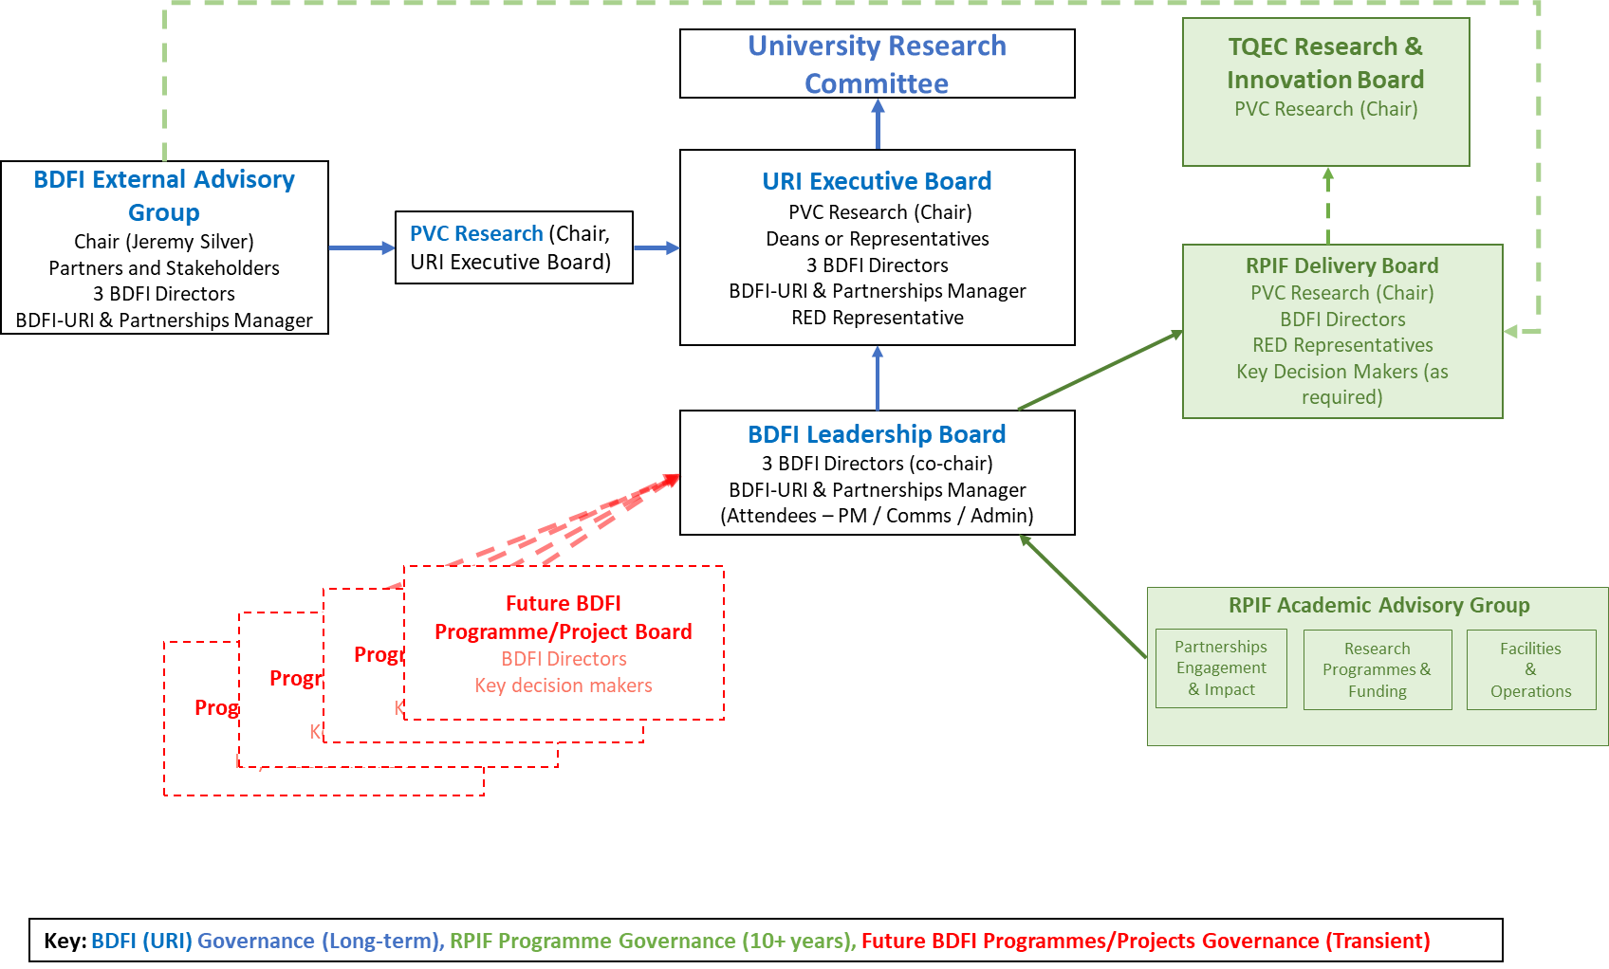

The AAG will provide minutes and a brief report to the RPIF Delivery Board following every meeting.
Decisions relating to spend of RPIF awarded funds will be considered by the RPIF Delivery Board and be communicated to the AAG for information.
AAG members will also liaise with and report on matters relating to BDFI and RPIF as appropriate to the BDFI Leadership Board outside of formal meetings.6.

8.0 Initial BDFI Build Timeline
The RPIF funding must be spent by 31 March 2022.
The TQEC-The Sheds Building Phase 1 is due to open January 2022
The TQEC-The Sheds Building Phase 2 is due to open in January 2023
The TQEC-CM1 Building is due to open in October 2025.
RPIF outcomes delivery 10-year period ends March 2031, but some flexibility on this can be agreed with the funder Research England.

